The Purpose of Canning\n

\n

The purpose of water bathing or steaming the cans is to annihilate any dangerous pathogens found in the food objects. Common bacteria such as Escherichia coli O157:H7, Salmonella enterica, Listeria monocytogenes and other pathogenic bacteria might be present in the product and can easily thrive in watery conditions. Even in acidic conditions some microorganisms can thrive which is why water bathing is essential for canning. Oxygen is also driven out of the cans which can help further kill microorganisms as they are aerobic organisms.\n

\n

Water bath canner is used for acidic foods like tomatoes, pickles, jams, chutneys, and other acidic food items with added acid.\n

\n

Water bath canner, pressure canner left to right\n

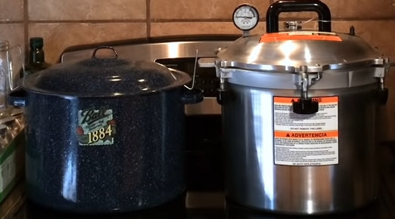

As high-PH foods cannot be water bathed, they must be pressure canned. Else it could cause complications from consuming wrongly preserved foods. The reason for this is that bacteria that grows from low-acid foods die at temperatures of 115 degrees Celsius or 240 degrees Fahrenheit. The water bath canner cannot reach that temperature as it has been tested that the jars can never exceed 100 degrees Celsius. Hence pressure canners must be used to can low acid foods safely.\n

\n

Pressure canners are used to can low acid foods such as potatoes, meats, green beans. Sometimes there are a variety of hybrid equipment so that it can be used to can both acidic and alkaline foods. Generally alkaline foods need to be preserved with citric acid or any solvent that is highly acidic to be canned safely.\n

\n  
Electric canners are not approved by the NCHP or USDA but there have been instances where electric canning may have been considered convenient regardless of the food authority’s reticence on using these versatile cookers. Ultimately, the testing done on the electric multi-purpose canners are not fully developed or that they provide unreliable result for you.\n

\n

Jars\n

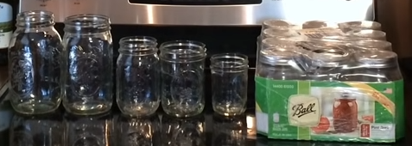

Low quality store-bought jars come from China and using other low-quality contaminated containers can hamper the progress of preserving food. Reliable mason jar manufacturers such as Ball or Kerr have been proven by the USDA for usage in Oven Canners.\n

\n

Other tools for canning.\n

Lid grabber, can grabber, measurement ruler, funnels\n

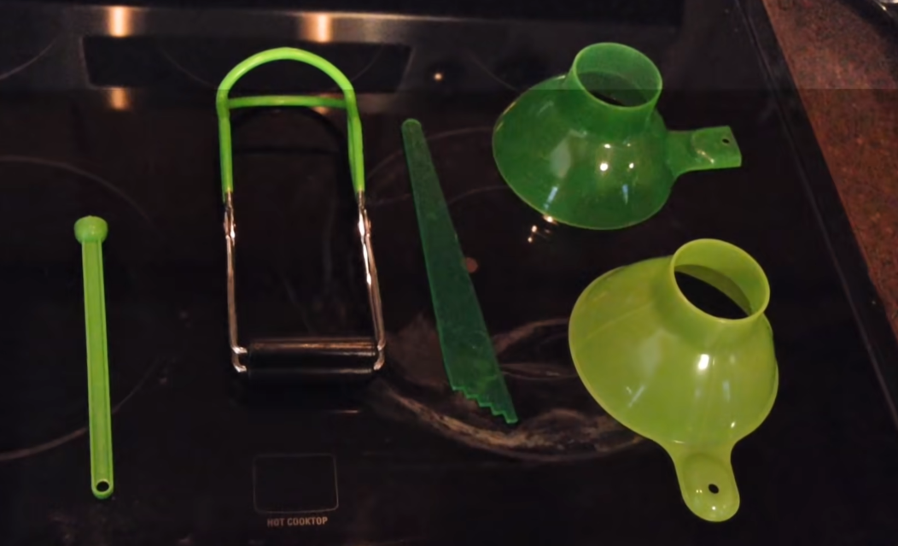

These tools are used to handle the cans without harm from the canner as the main issue with handling the cans are the high temperatures of the cans causing burns.\n